

Year 9 (Grade 8) Pre-test

English First Language

Instructions:

You have 60 minutes to complete this exam. Please write your name and school below and answer all of the following questions carefully.

Name:

_____________________________________________________________________

School:

_____________________________________________________________________

Examiner Only:
Score: ___/44

Section A: Grammar & Sentences (5 marks)
- Choose the most grammatically appropriate sentence: (1 mark)
A. The dinosaurs was extinct sixty-five million years ago.
B. The dinosaurs had been extinct sixty-five million years ago.
C. The dinosaurs went extinct sixty-five million years ago.
D. The dinosaurs have went extinct sixty-five million years ago.
- Identify and underline the subordinate clause. (1 mark)
Although he disagreed, he listened carefully.
- Circle the most appropriate connective: (1 mark)
Alescia’s argument was convincing; ______, it lacked evidence and was not considered a valid testimony.
A. however
B. therefore
C. because
D. moreover
- Which of the following is an example of hyperbole? Circle the correct answer: (1 mark)
A. I waited a thousand years for the bus to arrive.
B. The sun rose slowly over the quiet town.
C. Her voice was as soft as a whisper.
D. The classroom was silent when the teacher entered.

- Which sentence below is grammatically accurate and correctly punctuated? (1 mark)
A. Although pandas, once considered endangered creatures ongoing conservation efforts have helped revive their population.
B. Although pandas were once considered endangered creatures, ongoing conservation effort have helped revive its population.
C. Although pandas were once considered endangered creatures but ongoing conservation efforts have helped revive their population.
D. Although pandas were once considered endangered creatures, ongoing conservation efforts have helped revive their population.

Section B: Vocabulary (4 marks)
- Choose the closest meaning to “inevitable.” (1 mark)
A. avoidable
B. unavoidable
C. surprising
D. elusive
- Choose the most appropriate word: (1 mark)
The speaker’s argument was clear, logical, and highly ________, convincing even those who initially disagreed.
A. persuasive
B. aggressive
C. reluctant
D. accidental

- Choose the option that completes the sentence so that it is grammatically accurate and correctly punctuated. (1 mark)
At the Lancaster Royal Grammar School, a young Richard Owen was often described as being impudent. He got into fights from an early age and frequently snobbed the likes of Charles Darwin and Gideon Mantell. So it came as a surprise to everyone when he became the man to coin the term “dinosaur” for a collection of prehistoric reptiles that once ruled the Earth. He would also become the very first ________.
A. paleontologist, a scientist dedicated to the study of prehistoric life on Earth
B. paleontologist a scientist dedicated to the study of prehistoric life on Earth
C. paleontologist; a scientist dedicated to the study of prehistoric life on Earth
D. paleontologist - a scientist dedicated to the study of prehistoric life on Earth
- Which word best completes the sentence below? (1 mark)
Despite the teacher’s clear explanation, the instructions remained ________ to several students.
A. obvious
B. confusing
C. repetitive
D. efficient

Section C: Reading (10 marks)
The following is an extract from Cormac McCarthy’s The Road (2006), a story following a father and son surviving the post-apocalyptic wasteland of the USA.
When he woke in the woods in the dark and the cold of the night he'd reach out to touch the child sleeping beside him. Nights dark beyond darkness and the days more gray each one than what had gone before. Like the onset of some cold glaucoma* dimming away the world. His hand rose and fell softly with each precious breath. He pushed away the plastic tarpaulin and raised himself in the stinking robes and blankets and looked toward the east for any light but there was none. In the dream from which he'd awakened he had wandered in a cave where the child led him by the hand. Their light playing over the wet flowstone walls. Like pilgrims in a fable swallowed up and lost among the inward parts of some granitic beast. Deep stone flues where the water dripped and sang. Tolling in the silence the minutes of the earth and the hours and the days of it and the years without cease. Until they stood in a great stone room where lay a black and ancient lake. And on the far shore a creature that raised its dripping mouth from the rimstone pool and stared into the light with eyes dead white and sightless as the eggs of spiders. It swung its head low over the water as if to take the scent of what it could not see. Crouching there pale and naked and translucent, its alabaster bones cast up in shadow on the rocks behind it. Its bowels, its beating heart. The brain that pulsed in a dull glass bell. It swung its head from side to side and then gave out a low moan and turned and lurched away and loped soundlessly into the dark.
With the first gray light he rose and left the boy sleeping and walked out to the road and squatted and studied the country to the south. Barren, silent, godless. He thought the month was October but he wasn't sure. He hadn't kept a calendar for years. They were moving south. There'd be no surviving another winter here.
When it was light enough to use the binoculars he glassed the valley below. Everything paling away into the murk. The soft ash blowing in loose swirls over the blacktop. He studied what he could see. The segments of road down there among the dead trees. Looking for anything of color. Any movement. Any trace of standing smoke. He lowered the glasses and pulled down the cotton mask from his face and wiped his nose on the back of his wrist and then glassed the country again. Then he just sat there holding the binoculars and watching the ashen daylight congeal over the land. He knew only that the child was his warrant. He said: If he is not the word of God God never spoke.
When he got back the boy was still asleep. He pulled the blue plastic tarp off of him and folded it and carried it out to the grocery cart and packed it and came back with their plates and some cornmeal cakes in a plastic bag and a plastic bottle of syrup. He spread the small tarp they used for a table on the ground and laid everything out and he took the pistol from his belt and laid it on the cloth and then he just sat watching the boy sleep. He'd pulled away his mask in the night and it was buried somewhere in the blankets. He watched the boy and he looked out through the trees toward the road. This was not a safe place. They could be seen from the road now it was day. The boy turned in the blankets. Then he opened his eyes. Hi, Papa, he said.
I'm right here.
I know.
*an eye condition that gradually causes blindness

- How does the writer use imagery in the opening paragraph to convey the bleakness of the world? (2 marks)
_________________________________________________________________________
_________________________________________________________________________
_________________________________________________________________________
_________________________________________________________________________
_________________________________________________________________________
_________________________________________________________________________

- What is suggested by the simile “Like the onset of some cold glaucoma dimming away the world”? (2 marks)
_________________________________________________________________________
_________________________________________________________________________
_________________________________________________________________________
_________________________________________________________________________
_________________________________________________________________________
_________________________________________________________________________
- How does the description of the cave and the creature in the dream reflect the man’s fears about the world he and the child are living in?
Support your answer with one or two references to the extract. (2 marks)
_________________________________________________________________________
_________________________________________________________________________
_________________________________________________________________________
_________________________________________________________________________
_________________________________________________________________________
_________________________________________________________________________
- Identify two words or phrases from the extract that create a sense of fear or unease. (2 marks)
_________________________________________________________________________
_________________________________________________________________________
_________________________________________________________________________
_________________________________________________________________________
_________________________________________________________________________
_________________________________________________________________________
- How does the writer show the man’s protective feelings towards the boy in this passage? [2 marks]
_________________________________________________________________________
_________________________________________________________________________
_________________________________________________________________________
_________________________________________________________________________
_________________________________________________________________________
_________________________________________________________________________

Section D: Writing (25 marks)
15.) Write a short descriptive piece (minimum 100 words) that captures the scene depicted in the photograph below. You should focus on atmosphere rather than action and use sensory details to bring the scene to life.
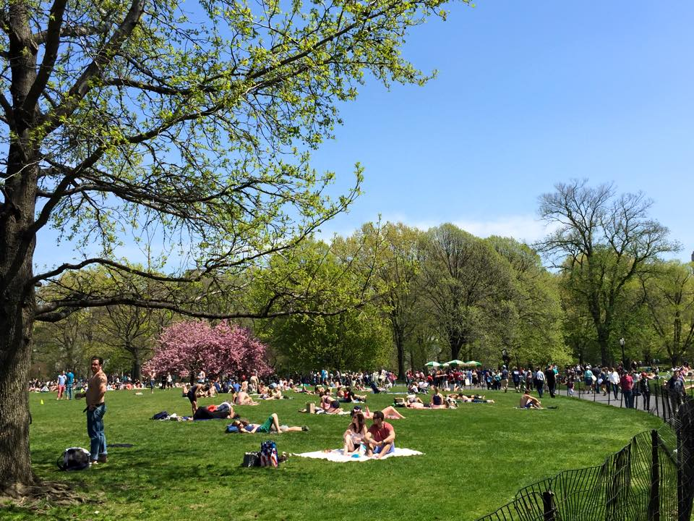
Write your answer below:

_________________________________________________________________________
_________________________________________________________________________
_________________________________________________________________________
_________________________________________________________________________
_________________________________________________________________________
_________________________________________________________________________
_________________________________________________________________________
_________________________________________________________________________
_________________________________________________________________________
_________________________________________________________________________
_________________________________________________________________________
_________________________________________________________________________
_________________________________________________________________________
_________________________________________________________________________
_________________________________________________________________________
_________________________________________________________________________
_________________________________________________________________________
_________________________________________________________________________
_________________________________________________________________________
_________________________________________________________________________
_________________________________________________________________________
_________________________________________________________________________
_________________________________________________________________________
_________________________________________________________________________
_________________________________________________________________________
_________________________________________________________________________
_________________________________________________________________________
_________________________________________________________________________
_________________________________________________________________________
_________________________________________________________________________
_________________________________________________________________________
_________________________________________________________________________
_________________________________________________________________________
_________________________________________________________________________
_________________________________________________________________________

